### Lab 5 Use RYU to write a routing controller

Name: Eduardo Wang Zheng

E-mail: eduardo@sjtu.edu.cn

1. Experiments
   1. Set up the network

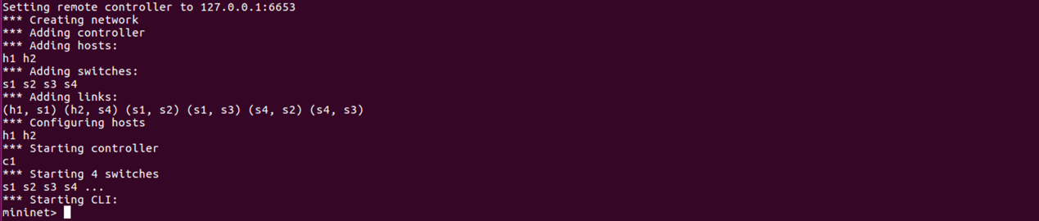

* 1. Write a RYU controller that switches paths (h1-s1-s3-s2-h2 or h1-s1-s4-s2-h2) between h1 and h2 every 5 seconds (Haven’t finished yet)
  2. Write a RYU controller that uses both paths to forward packets from h1 to h2
     1. Add flow rules and create group table for s1 and s4
        1. Key part of the code

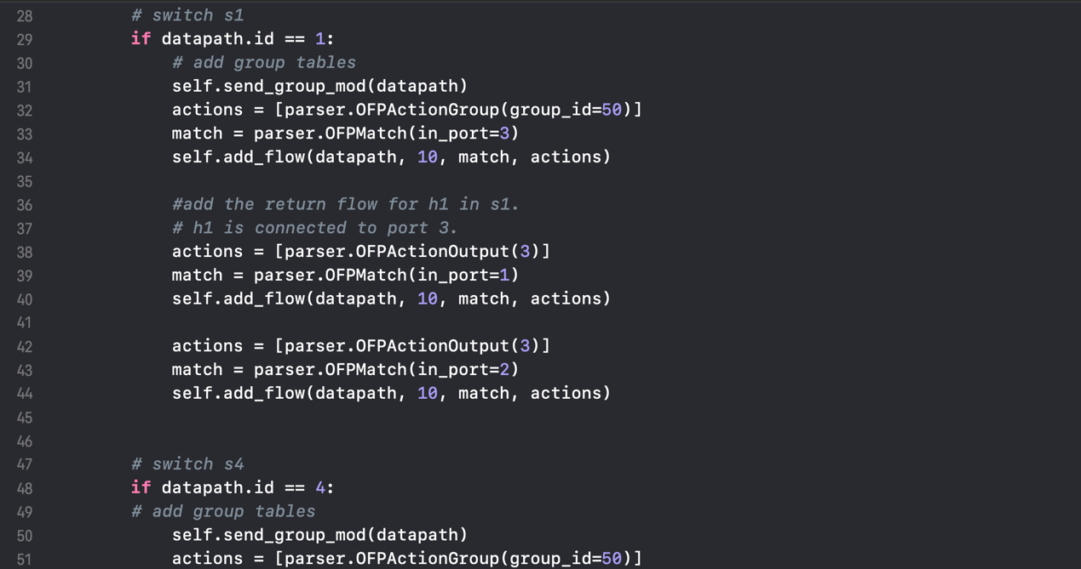

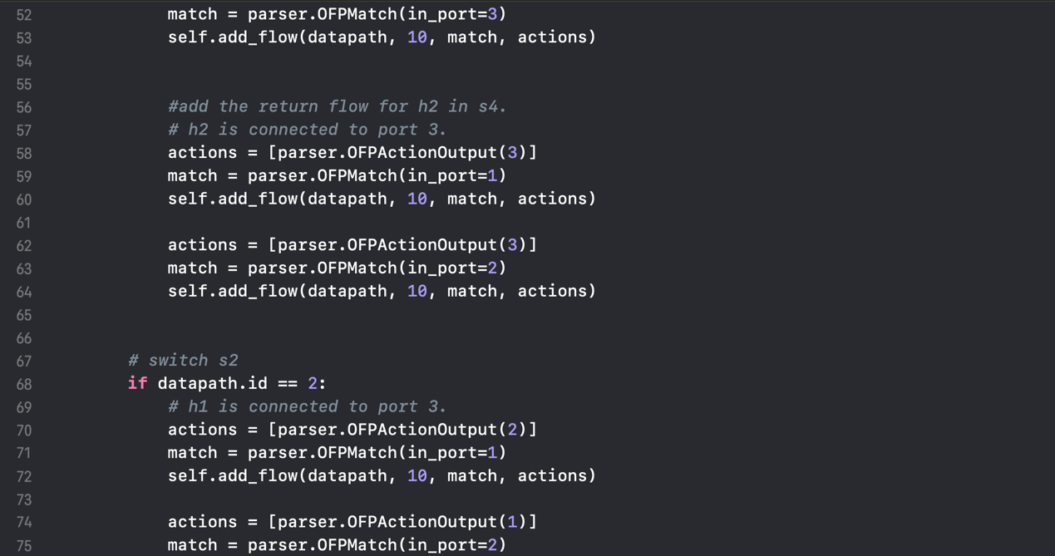

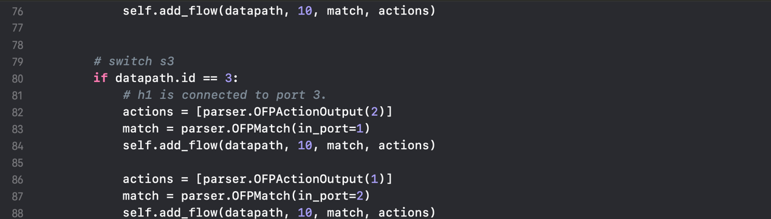

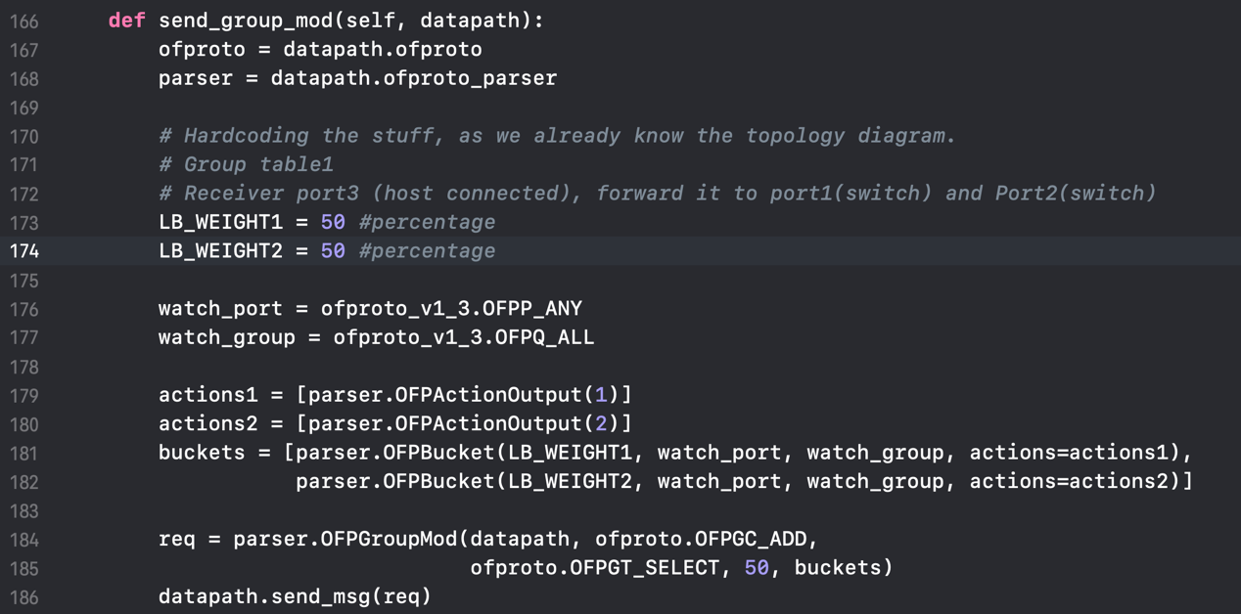

* + - 1. Evaluation



From the above figure, we can find that both buckets are used to forward the packets. The weights are 50 and 50, which is defined in the source code.

* 1. Write a RYU controller that uses the first path (h1-s1-s3-s2-h2) for routing packets from h1 to h2 and uses the second path for backup
     + 1. Key part of the code

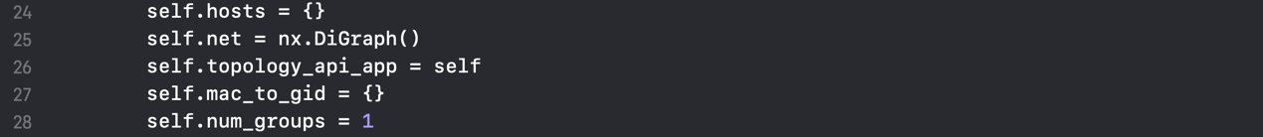

Changes in initialization



Changes in function ***switch_features_handler***

The above figure shows how to use OFPGT_FF (FF is short for "fast failover") to construct a default group table.

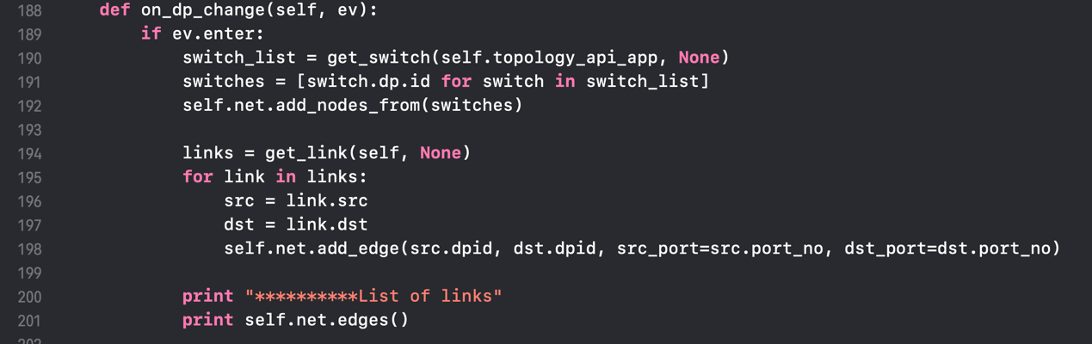

Detect the change of network topology and update currently stored topology

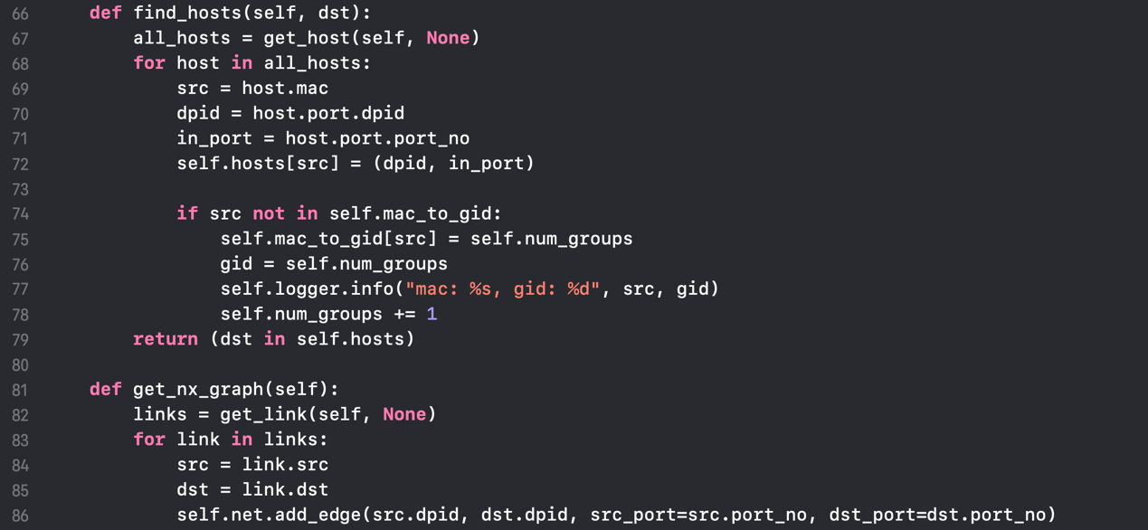

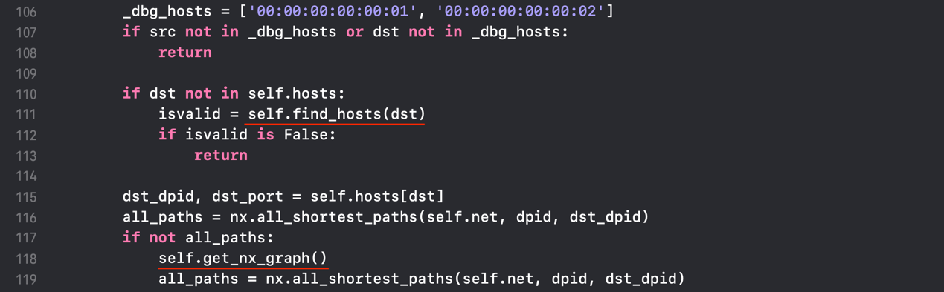

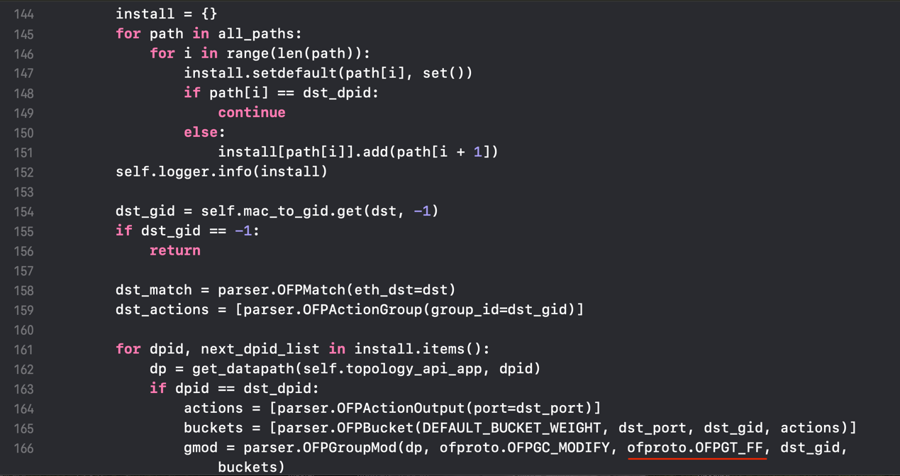

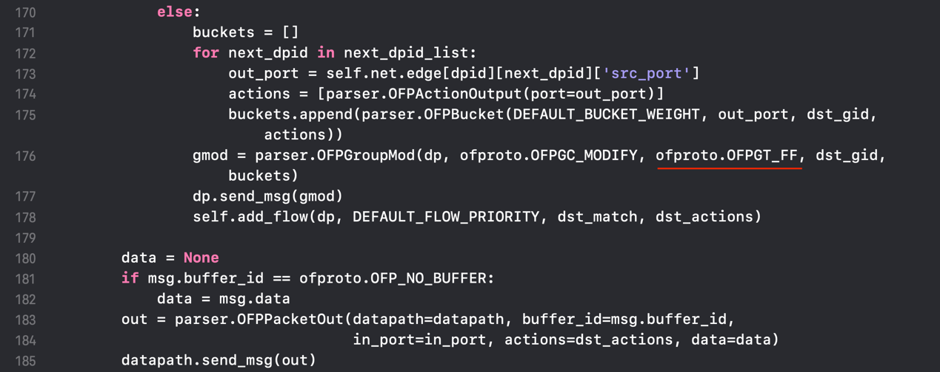

Changes in function ***_packet_in_handler***

I use red marks in the above figure to show how to use OFPGT_FF (FF is short for "fast failover") to set the group mode and how functions are called. Here is an example for all finding paths and data to install:

Topology like

/2\ /5\

h1-1 4 7-h2

\3/ \6/

all path from h1 to h2

[1, 2, 4, 5, 7]

[1, 2, 4, 6, 7]

[1, 3, 4, 5, 7]

[1, 3, 4, 6, 7]

data of to_install will be:

{

1: [2, 3],

2: [4],

3: [4],

4: [5, 6],

5: [7],

6: [7],

7: []

}

The key idea is setting up the group table and flow table for each switch according to all current paths.

* + - 1. Evaluation



From the above figure, we can find that both buckets are used to forward the packets at first.



Then I shut down the port 2 of s1.



I dump the group status again. Now we can find that only one bucket is used to forward the packets at this time.

* 1. Reference

<https://github.com/rex5207/SDN-FastFailover>